Carro esquiva obstáculos infrarrojo

1. Funcionamiento

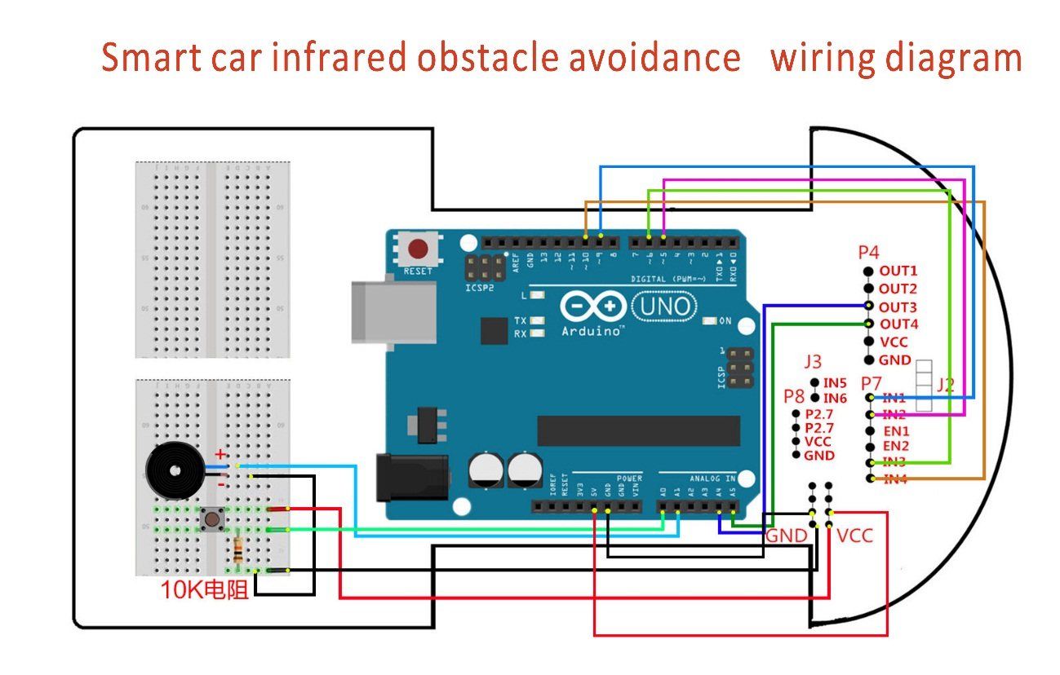

1. Código

int Left_motor_back=9; //(IN1)

int Left_motor_go=5; //(IN2)

int Right_motor_go=6; //(IN3)

int Right_motor_back=10; //(IN4)

const int SensorRight_2 = A4; //(P3.5 OUT4)

const int SensorLeft_2 = A5; //(P3.4 OUT3)

int SL_2;

int SR_2;

void setup()

{

pinMode(Left_motor_go,OUTPUT);

pinMode(Left_motor_back,OUTPUT);

pinMode(Right_motor_go,OUTPUT);

pinMode(Right_motor_back,OUTPUT);

pinMode(key,INPUT);

pinMode(beep,OUTPUT);

pinMode(SensorRight_2, INPUT);

pinMode(SensorLeft_2, INPUT);

}

void run()

{

digitalWrite(Right_motor_go,HIGH);

digitalWrite(Right_motor_back,LOW);

analogWrite(Right_motor_go,200);

analogWrite(Right_motor_back,0);

digitalWrite(Left_motor_go,HIGH);

digitalWrite(Left_motor_back,LOW);

analogWrite(Left_motor_go,200);

analogWrite(Left_motor_back,0);

}

void brake(int time)

{

digitalWrite(Right_motor_go,LOW);

digitalWrite(Right_motor_back,LOW);

digitalWrite(Left_motor_go,LOW);

digitalWrite(Left_motor_back,LOW);

delay(time * 100);

}

void left()

{

digitalWrite(Right_motor_go,HIGH);

digitalWrite(Right_motor_back,LOW);

analogWrite(Right_motor_go,175);

analogWrite(Right_motor_back,0);

digitalWrite(Left_motor_go,LOW);

digitalWrite(Left_motor_back,LOW);

analogWrite(Left_motor_go,0);

analogWrite(Left_motor_back,0);

}

void spin_left(int time)

{

digitalWrite(Right_motor_go,HIGH);

digitalWrite(Right_motor_back,LOW);

analogWrite(Right_motor_go,250);

analogWrite(Right_motor_back,0);

digitalWrite(Left_motor_go,LOW);

digitalWrite(Left_motor_back,HIGH);

analogWrite(Left_motor_go,0);

analogWrite(Left_motor_back,100);

delay(time * 100);

}

void right()

{

digitalWrite(Right_motor_go,LOW);

digitalWrite(Right_motor_back,LOW);

analogWrite(Right_motor_go,0);

analogWrite(Right_motor_back,0);

digitalWrite(Left_motor_go,HIGH);

digitalWrite(Left_motor_back,LOW);

analogWrite(Left_motor_go,175);

analogWrite(Left_motor_back,0);

}

void spin_right(int time)

{

digitalWrite(Right_motor_go,LOW);

digitalWrite(Right_motor_back,HIGH);

analogWrite(Right_motor_go,0);

analogWrite(Right_motor_back,100);

digitalWrite(Left_motor_go,HIGH);

digitalWrite(Left_motor_back,LOW);

analogWrite(Left_motor_go,100);

analogWrite(Left_motor_back,0);

delay(time * 100);

}

void back(int time)

{

digitalWrite(Right_motor_go,LOW);

digitalWrite(Right_motor_back,HIGH);

analogWrite(Right_motor_go,0);

analogWrite(Right_motor_back,100);

digitalWrite(Left_motor_go,LOW);

digitalWrite(Left_motor_back,HIGH);

analogWrite(Left_motor_go,0);

analogWrite(Left_motor_back,150);

delay(time * 100);

}

void loop()

{

while(1)

{

SR_2 = digitalRead(SensorRight_2);

SL_2 = digitalRead(SensorLeft_2);

if (SL_2 == HIGH&&SR_2==HIGH)

run();

else if (SL_2 == HIGH & SR_2 == LOW)

left();

else if (SR_2 == HIGH & SL_2 == LOW)

right();

else

back(15);

}

}